 | PES University, Bengaluru  (Established under Karnataka Act No. 16 of 2013) | UE18CS314
OCTOBER 2020: IN SEMESTER ASSESSMENT B Tech 5 SEMESTER
TEST  1 (Scheme and Solution)

UE18CS314 (4 credit)  APPLIED CRYPTOGRAPHY
Time: 2 Hrs | Answer All Questions | Max Marks: 60

1. | a) | For each of the following encryption schemes, state whether the scheme is perfectly secret. Justify your answer in each case  The message space is M = {0, 1, 2, 3, 4} Algorithm Gen choses a uniform key from the key space {0, 1, 2, 3, 4, 5} Enck (m) returns [k+ m mod 5] and Deck (c) returns [c-k mod 5].  Solution:  The scheme is not perfectly secret  According to probability distribution Pr[EncK(m) = c] = Pr[EncK(m’ ) = c]  In the above problem  If the message is 0, then the ciphertext is 0 if and only if k ∈ {0, 5}.  So Pr[EncK(0) = 0] = 1/3. On the other hand, if the message is 1, then the ciphertext is 0 if and only if k = 4.  So Pr[EncK(1) = 0] = 1/6 ̸= Pr[EncK(0) = 0]. | 5
1. | b) | The message space is M = {m ∈ {0,1}^l | the last bit of m is 0}. Gen chooses a uniform key from {0,1} ^ l-1. Enc_{k} (m) returns cipher-text: m ⊕ (k||0), and Dec_{k} (c) returns c ⊕ (k||0). Note: || represents concatenation  Solution:  The scheme is perfectly secure  As the length of key is same as that of plaintext = l-1  And key is chosen uniformly which is same as one time pad.  According to probability distribution equation Pr[EncK(m) = c] = Pr[EncK(m’ ) = c]  Pr(0) = pr(1) = 0.5 | 5
2. | a) | Alice needs to send the message Enemy attacks tonight to Bob. Use double columnar transposition cipher to find ciphertext with keys = {Crypt, Perfect}.  Solution:  Ciphertext with key = CRYPT  EAKIMAOTNTSGYCNZETTH  Ciphertext with key = PERFECT  AYHANZMGTISTETNKTEOCZ | 4
2. | b) | Define Pseudo Random Permutation with example.  Solution:  A Pseudo Random Permutation is a PRF that happens to have the property that every element in the input domain has a single associated member in the output co-domain. PRP is a bijection function (one-to-one mapping). PRP is invertible.  Example: AES substitution and inverse substitution | 3
2. | c) | Explain the working of one-time pad.  Solution:  The encryption-key has at least the same length as the plaintext and consists of truly random numbers  Each letter of the plaintext is 'mixed' with one element from the random number which is chosen from one-time password (OTP)  This results in a ciphertext that has no relation with the plaintext when the key is unknown. At the receiving end, the same OTP is used to retrieve the original plaintext | 3
3. | a) | Why Permutation, Substitution used in DES encryption Algorithm?  Solution:  The S-boxes or substitution do the real mixing (confusion). DES uses 8 S-boxes, each with a 6-bit input and a 4-bit output. Design S-boxes and mixing permutation (E-box) to ensure avalanche effect. Small differences should eventually propagate to entire output 1-bit change in input causes ≥2-bit change in output.  In DES has an initial permutation and final permutation these permutations are inverse of each other and operate on 64 bits. They make implementation easier with respect to hardware circuit. | 4
3. | b) | Given the s-box for s0 find the output for 011010 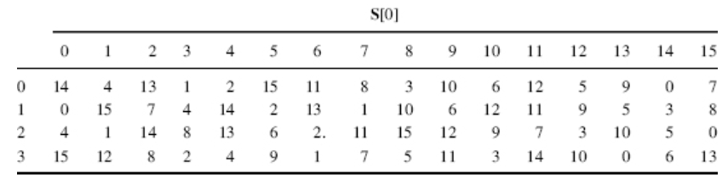  Solution:  Row: first and last bit =00  Col: middle 4 bit = 1101 =D  Final output = 0th row 13 th col = 9 | 2
3. | c) | Explain the working of triple-DES.  Solution:  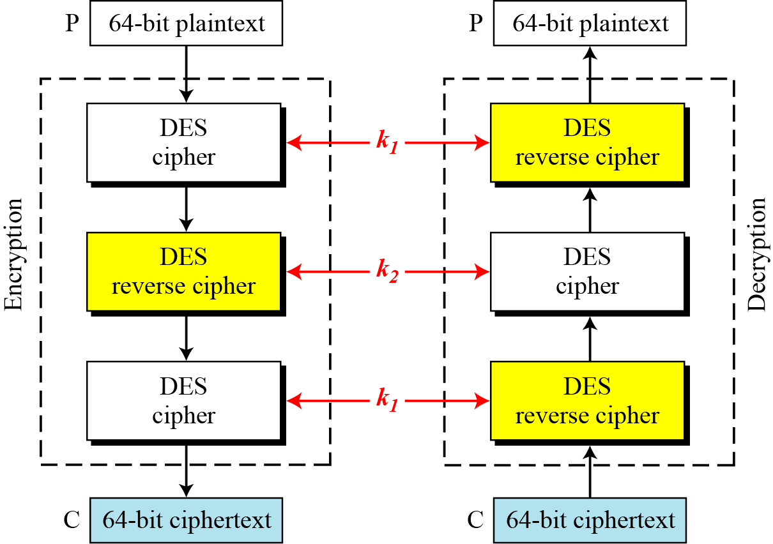  Explanation:  The possibility of known-plaintext attacks on triple DES with two keys has enticed some applications to use triple DES with three keys. Triple DES with three keys is used by many applications such as PGP | 4
4. | a) | Explain key expansion algorithm of AES for key “BEST CRYPTOGRAPHY” for first set of key with rcon given by.  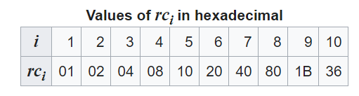  Solution:  STATE  B C T A  E R O P  S Y G H  T P R Y  W1 W2 W3 W4  01 02 13 00  04 11 0E 0F  12 18 06 07  13 0F 11 18  W5 = Circular column shift of 1 byte (w4) xor rcon1 xor w1  W6 = w5 xor w2  W7 = w6 xor w3  W8 = w7 xor w4 | 5
  A | B | C | D | E | F | G | H | I | J | K | L | M
  00 | 01 | 02 | 03 | 04 | 05 | 06 | 07 | 08 | 09 | 0A | 0B | 0C
  N | O | P | Q | R | S | T | U | V | W | X | Y | Z
  0D | 0E | 0F | 10 | 11 | 12 | 13 | 14 | 15 | 16 | 17 | 18 | 19
4. | b) | Given below is the state of some intermediate shift row output find the output for one column mixcolumn step of AES given matrix of GF(2⁸)  Output of siftrow= 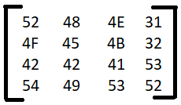 matrix GF= 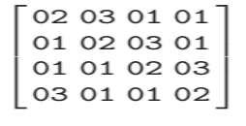  Solution:  1 column:  52*02 XOR 03*4F XOR 42*01 XOR 54*01  52*01 XOR 02*4F XOR 42*03 XOR 54*01  52*01 XOR 01*4F XOR 42*02 XOR 54*03  52*03 XOR 01*4F XOR 42*01 XOR 54*02  For multiplication by 1:  Retain the same value.  For multiplication by 2:  Check the MSB  Left shift the value by 1 bit .  IF MSB was 1 before shift XOR with 1B.  For multiplication by 3:  Follow steps for multiplication by 2.  XOR withoriginal value. | 5
5. | a) | Consider a stateful variant of CBC-mode encryption where the sender simply increments the IV by 1 each time a message is encrypted (rather than choosing IV at random each time). Show that the resulting scheme is not CPA-secure.  Solution:  Solution:  Define A as follows:  (a) Query the encryption with the message m = 0^{n−1}∥1. Receive in return a ciphertext ⟨IV, c⟩.  (b) If IV is odd (i.e., has low-order bit 1), then output a random bit.  (c) If IV is even, then output a pair of messages m₀, m₁ where m0 = 0^{n} and m1 is any other message. Receive in return a challenge ciphertext ⟨IV + 1, c′ ⟩.  (d) If c′ = c output 0; else output 1.  We analyze the success probability of A. If IV is odd, then A succeeds exactly half the time. For any even IV , though, it holds that IV +1= IV ⊕ (0^{n−1}∥1). Thus, for any even IV we have c = Fk(IV ⊕ m) = Fk(IV ⊕ 0^{n−1}1 ⊕ m ⊕ 0^{n−1}1) = Fk((IV + 1) ⊕ m0). So if m0 is encrypted then c′ = c and A outputs 0, while if m1 is encrypted then c′ != c and A outputs 1. The overall success probability of A is therefore 3/4, and this modified CBC mode is not CPA-secure. | 4
5. | b) | What is the value of (240)?  Solution:  Factors: 2⁴ * 5 *3  (240) = (2⁴-2³) * (5-1) * (3-1) =  64 | 2
5. | c) | If Allice, bob chose prime number as 23 and its primitive root 9. Allice choses private key as 4 and bob private key as 3, find the shared key?  Solution:  p=9 q=23  K_{a}=4 k_{b}=3  Allice finds A= 9⁴ mod 23 and sends A to Bob, Bob finds B = 9³ mod 23 and sends B to allice  A= 6 B= 16  Allice does S=B ^{Ka} mod 23 Bob does S= A ^{K}_{b} mod 23  S=16 ⁴ mod 23 S= 6 ³ mod 23  S= 9 S= 9  Secret key = 9 | 4
6 | a) | What is the effect of a single-bit error in the ciphertext when using the CBC, OFB, CFB and CTR modes of operation?  Solution:  CBC: it will mess up the whole corresponding plaintext block and invert the corresponding bit in the next plaintext block.  OFB: it will invert the corresponding bit in the corresponding plaintext block.  CFB: it will invert the corresponding bit in the same plaintext block and mess up the whole next plaintext block.  CTR: it will invert the corresponding bit in the corresponding plaintext block. | 4
 | b) | In RSA: Given p=19, q=23 and e=3 find d  Solution:  Let p = 19, q = 23  n = p*q = 437  (n) =(p-1) * (q-1) = 396  For e=3 cannot find d  select e=5 as gcd (e, (n)) =1  d=317  pk = (5, 437) sk = (396, 437) | 6

